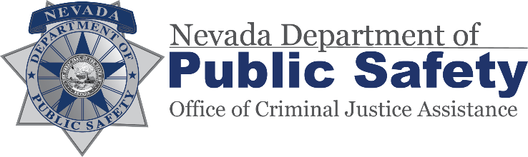 | Monthly Progress Report  Reports due 25th of the month

Subgrantee/Recipient

Agency Name |  | Reporting Period
Address |  | Date report completed
City/State/Zip |  | Phone
Project Title |  | Project Grant #
Report Prepared by |  | Preparer’s Title
E-mail Address

Final Report (cumulative) 45 days after project end.

CERTIFICATION: I understand that any deviation from the programmatic or financial plans in the approved grant must first receive prior written approval from the Department of Public Safety, Office of Criminal Justice Assistance before implementation. As an authorized individual agreeing to comply with the general and fiscal terms and conditions including special conditions of this grant, I certify the information contained in this report is accurate and, to the best of my knowledge, program expenditures and activities are in compliance with the approved grant and federal/state regulations.

Please Type Name & Title
Signature of Project Director (as listed in the grant award) |  | Date:

We request that you include copies of press releases and news articles relating to the project. These articles can be from local or national newspapers and magazines, state or local reports or publications, and other news agencies.

Monthly Project Narrative:

Please provide detailed narrative responses to the following questions about your grant for the current month.
Answers in the shaded areas.

1. Are you on track to fiscally and programmatically with your program as outlined in your grant application? (Please answer YES or NO. If no, please explain.) YES NO
2. What Goals were accomplished as they relate to your grant application within this reporting period? Include training attended or equipment purchased.
3. What challenges did you encounter, if any, within the reporting period?
4. What major activities are planned for the next 6 months?
5. Based on your knowledge of the criminal justice field, are there any innovative programs/accomplishments that you would like to share with OCJA?
6. Is there any programmatic assistance that OCJA can provide to address any challenges identified in question #3 above? (Please answer YES or NO only.) _____ YES _____NO
7. Listed below is space for your agency’s Goals and Objectives from your grant application. Please fill in your agency’s Goals and Objectives, then answer the following questions for each Goal and Objective:
- WHAT was done?
- WHO completed the tasks?
- WHEN did the activities occur?
- HOW is this benefiting the agency or community? Include a narrative of this grant’s statistical measures. Include all activities planned for the next 3 months.
- INCLUDE an updated timeline if it has changed from the original; this demonstrates you have thought through your program.

- INCLUDE statistical charts, spreadsheets and/or supporting documents. (Unless you are writing about purchasing equipment or supplies, travel or training, statistical data is expected.)
- AVOID the words might, if, could, should, would.
If the project on hold or not working, please explain why and what the next steps are to work through the problems. Include what changes will be made.
8. Goal #1 is :
Objectives:

Objective # 1

Objective # 2
9. Goal #2:
Objectives:

Objective # 1

Objective # 2
10. Goal #3:
Objectives:

Sub-recipient COMMENTS:

OCJA PROGRAM MANAGER’S COMMENTS (For OCJA use only):

DPS/OCJA Program Manager’s Signature Date

